VISUALIZING TIME SERIES DATA

About the Project : The project deals with the unemployment information form the years 1976 to 2016. The data is in the format of CSV. The main screen or the homepage which has the Texas state graph drawn on it . Map of the united states of America is provided to help the users visually select the state. Multiple states can be selected at hence. Rest button is provided to clear off all the states.
When the user hovers on the map as well as the graph line a tool tip is designed to help the user to know the state. National unemployment rate of US is also been added .
If the user selects the check box national unemployment rate can be seen. The rise and drop in the percentage of unemployment can also be seen. Attached below are the Screen Shots of the project.

Software Requirements:
Text Editor: Notepad ++
Languages used : javascript and D3
Operating System: windows 7/8/10
Server : wamp server
Code Repository : Git hub Pages

SCREENSHOTS
The First screen shot consists of only Texas state Unemployment Graph.

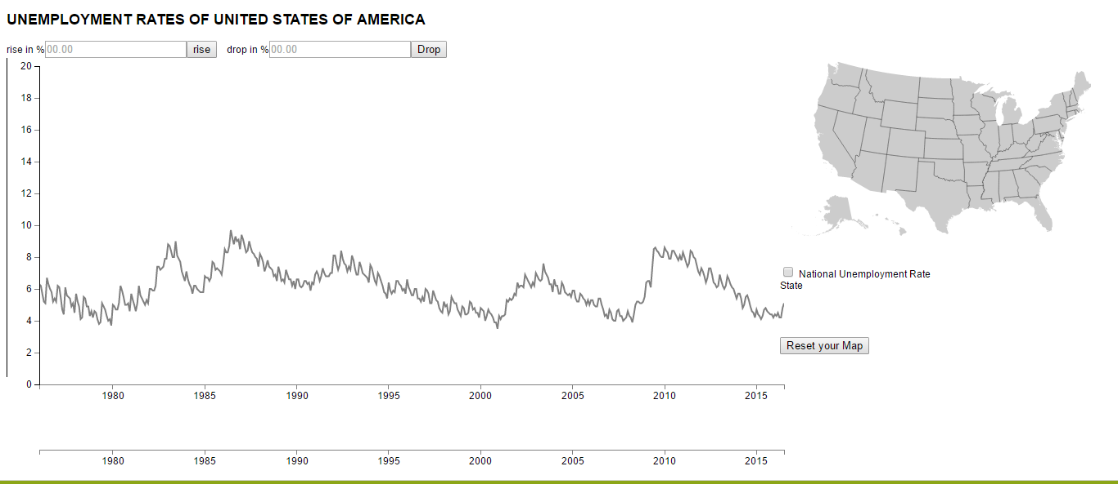

In this screen shot you can see the multiple state selection with tool tip indicating the name of the state hovered on .
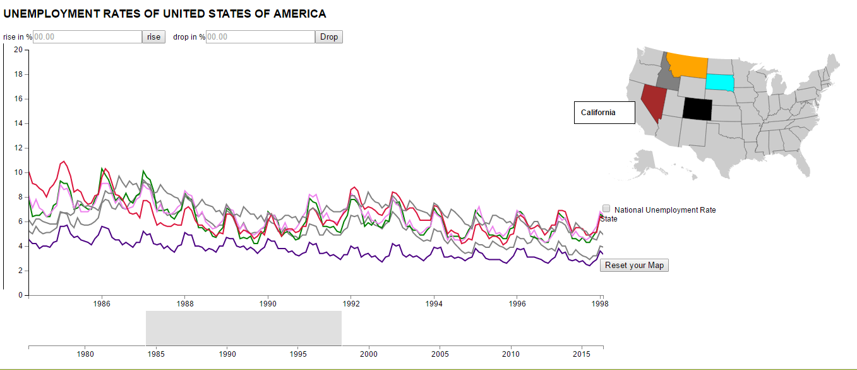

This shot shows the multiple state selection with comparison of National unemployment rate selection
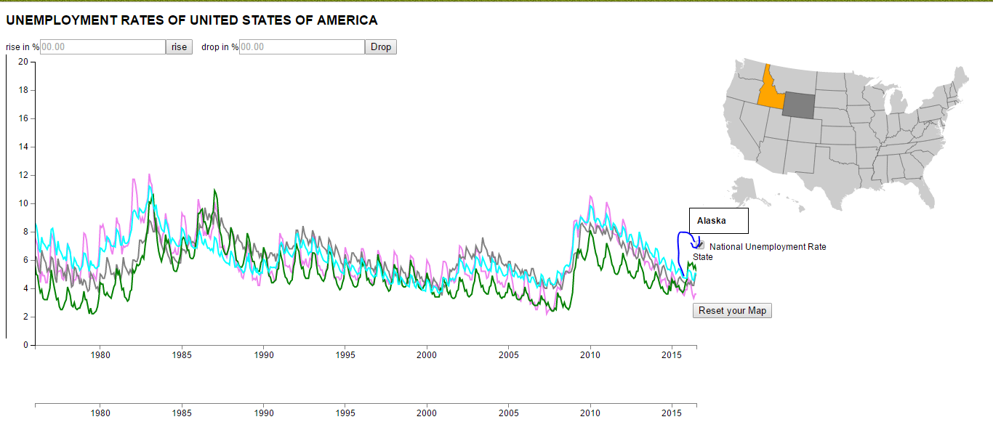
This screen shot shows the drop in percentage of 7 for the selected state
